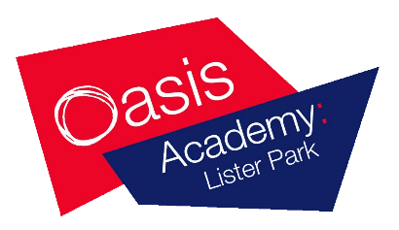
Post 16
Application Form

Please complete all sections of this form in CAPITAL LETTERS.

Date: | Address:
Surname:

First Names (underline the one normally used):

Please tick: Male Female | Postcode:
Date of Birth: | Current School:  Tutor group:
Home Telephone Number: | Mobile Number:

Qualifications
In this section please list either your predicted GCSE/BTEC grades or your actual GCSE/BTEC grades if you have them.

GCSE or BTEC | Subject | Predicted  Grade | Actual  Grade (if applicable)

Please turn over and complete the back of this form

For Official Use only:
Date Rec’d |  | Interview date |  | Interviewer

Making Your Choices – Please tick your choices:

- For students who achieve at least 5 GCSEs grades 4 or above choose 3 or 4 level 3 subjects (Please see individual subject information sheet for specific entry requirements).

- Students who achieve at least 4 grade 3 including English and Maths can choose Level 2 subjects.

Level 3 A-Level & BTEC/Diploma Subjects |  | Level 2 Subjects
Sociology |  | English GCSE RESIT
Psychology |  | Maths GCSE Resit
L3 Extended Certificate in Business |  | Level 2 (Certificate in Finance, Being Entrepreneurial, Employability Skills)
L3 Extended Certificate in Health and Social Care
L3 Extended Certificate in ICT
L3 Extended Certificate in Science
L3 Extended Certificate in Sport

Courses will run subject to numbers.

In the space below I would like you to tell me what you would like to do when you leave school and how the subjects you have selected will help you get there.

Please provide the details below for a referee at your current school (External Students Only)

Name of Referee:
Job Title
Email Address
Telephone Number:

Email Applications to: Neharun.aziz@oasislisterpark.org

Please send completed application forms to:

Mrs M Mahmood
Post 16 Office
Oasis Academy Lister Park
North Avenue
Bradford
BD8 7ND

