Instructions:
You need to complete 1 homework per week.
You may choose a homework of your choice for each week but you must attempt one from each category over the half term.
Week | Performance – Lunchtime | Composition – Lunchtime session | Listening – In your Book | Knowledge and Understanding – In your Book
1 – Strings Week  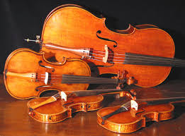 | Practice your performance of Superman and show this to a coach/Year 11.  You must get your booklet signed. | Create a drum beat that could be added to the Superman Theme.  Show this to a coach/ Year 11 and get your booklet signed. | Listen to the Superman theme song and answer the following questions.  - What string instruments can you hear?  - What is a role of the strings? | Evaluate how successful your practice was today and answer the following questions:  WWW  EBI?  Target -
Grade | Grade 1 - Students can sing in tune and perform rhythmically simple parts. | Grade 1 - Students recognise and explore how sounds can be combined. | Grade 1- Identify different stringed instruments in musical extracts. | Grade 1 - Students can identify where their work is successful.
2 – Brass Week  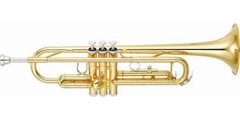 | Practice your performance of Everybody Needs Somebody and show this to a coach/Year 11.  You must get your booklet signed. | Create lyrics that could be added to the Everybody Needs Somebody. Show this to a coach/ Year 11 and get your booklet signed. | Listen to the piece Everybody Needs Somebody by The Blues Brothers and answer the following questions.  - What Brass instruments can you hear?  - What is a role of the Brass? | Evaluate how successful your practice was today and answer the following questions:  WWW  EBI?  Target -
Grade | Grade 1 - Students can sing in tune and perform rhythmically simple parts. | Grade 1 - Students recognise and explore how sounds can be combined. | Grade 1- Identify different stringed instruments in musical extracts. | Grade 1 - Students can identify where their work is successful.
3 – Woodwind Week  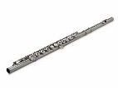 | Practice your performance of Morning (left hand in bass clef) and show this to a coach/Year 11.  You must get your booklet signed. | Write out the left hand piano part and identify all the notes by putting the correct letters underneath. Show this to a coach/ Year 11 and get your booklet signed | Listen to the piece Morning by Peer Gynt and answer the following questions.  - What Woodwind instruments can you hear?  - What is a role of the Woodwind?  - Where do you think this Music is from and what event/place is this for? | Evaluate how successful your practice was today and answer the following questions:  WWW  EBI?  Target –  What steps do you need to take to improve your learning further?
Grade | Grade 1+ - Students can perform from more complex notation. | Grade 1+ - Students are able to use a variety of notations. | Grade 1+ - Students can discuss how music represents time, place and culture | Grade 1+ - They refine and improve their work.
4 – Percussion Week  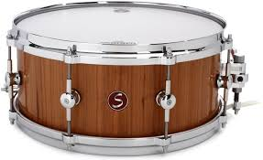 | Practice your drum beat and show it to a coach/Year 11.  You must get your booklet signed. | Create a drum beat that incorporates several percussion instruments.  Show this to a coach/ Year 11 and get your booklet signed. |  | Name 2 un-tuned percussion instruments.  Name 2 tuned percussion instruments.  Is the piano a percussion instrument?  Is the Snare part of the Drum Kit
Grade |  |  |  | Grade 1 - They can understand the different orchestral instruments.

