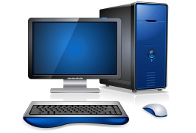What is inside my computer?

My Objective

*I can explain what hardware is inside a computer*

Task 1: True or False  
Watch the video in lesson and decide if the following statements are true or false? Circle the correct answer.

1. CPU stands for Computer Professional Unit. **True/False**
2. The CPU is often referred to as the “Brain” of the computer. **True/False**
3. RAM is where you store your work files e.g. a presentation. **True/False**
4. Hard drives are slower but cheaper than solid state drives. **True/False**
5. Expansion slots can be used to upgrade a computer. **True/False**

**Mark**

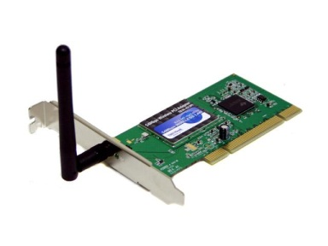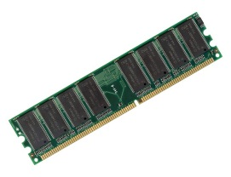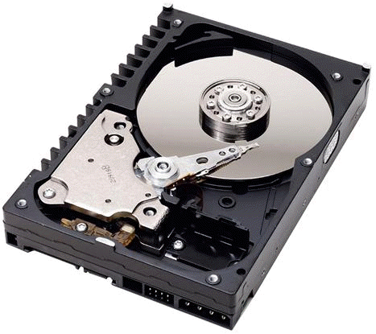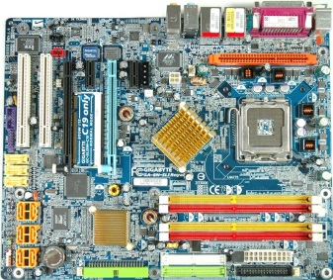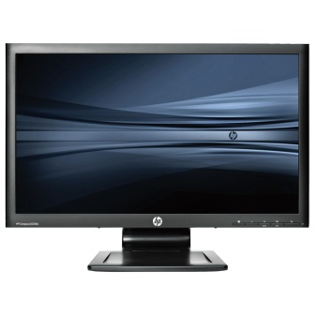[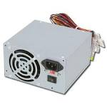](http://www.google.co.uk/imgres?imgurl=http://images.maplin.co.uk/full/a05bk.jpg&imgrefurl=http://www.maplin.co.uk/300w-power-supply-32149&usg=__JC6e3jrXunEIxreMJdm02UGwMEQ=&h=1024&w=1024&sz=188&hl=en&start=4&zoom=1&tbnid=w_P4rbgUd9_1lM:&tbnh=150&tbnw=150&ei=m2B1UYiNBqaw7Abi7YG4DQ&prev=/search%3Fq%3DPower%2Bsupply%26um%3D1%26safe%3Dvss%26sa%3DN%26hl%3Den%26sout%3D1%26tbm%3Disch&um=1&itbs=1&sa=X&ved=0CDIQrQMwAw)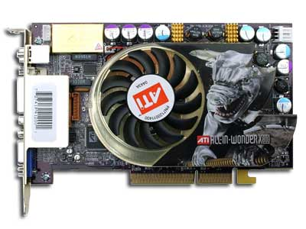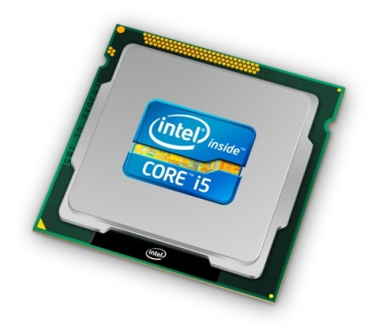

**Hardware**RAM Motherboard  
CPU Graphics Card  
Power Supplier Monitor/VDU  
Hard Drive   
Wireless Network Card

Task 2: Name that hardware  
Use the internet to identify what the different pieces of hardware are below.

/5