Year 10 Revision pack: A set of answers to improve
On Monday we began a pack of work using our reading skills, and you continued it for homework. The pack was basically an English Language Paper 1 exam:
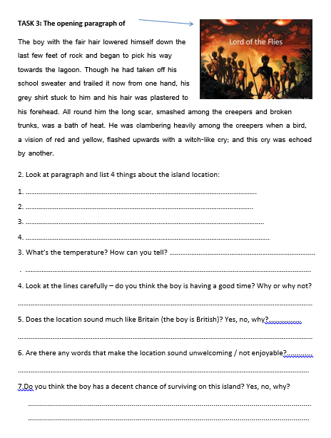
The ‘Name 4 things about the island’ question on this page is exactly the style of Question 1 – where you list 4 true things from a paragraph of your given text.

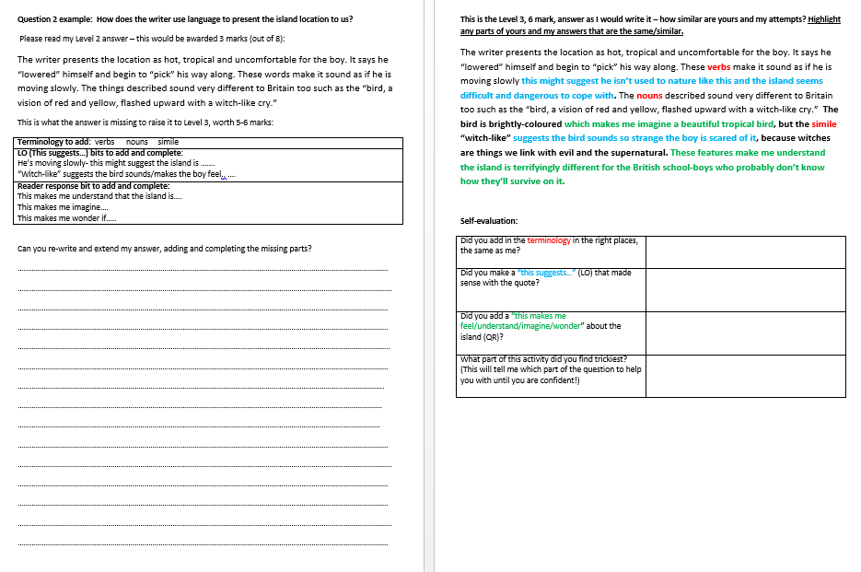

These 2 pages had a Question 2 example to improve – Question 2 is where you explain how words/phrases/similes etc give you an impression of something in your given text

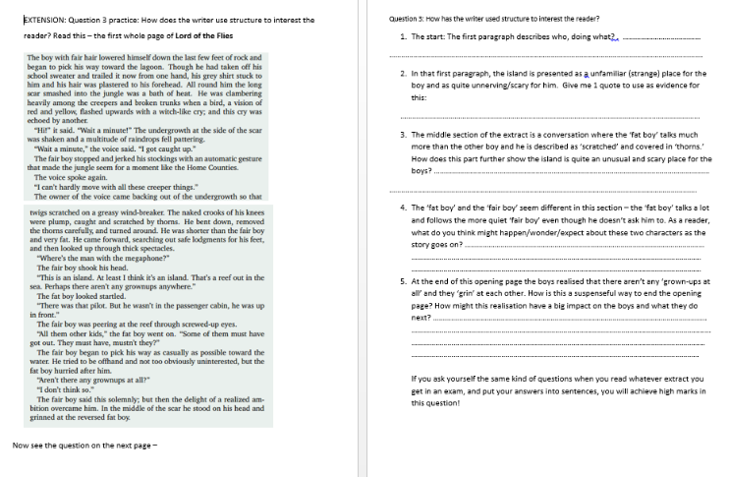
These pages had the whole extract to read and questions to help you put together a Question 3 answer – this is where you explain how the start/middle/end to the text make it interesting

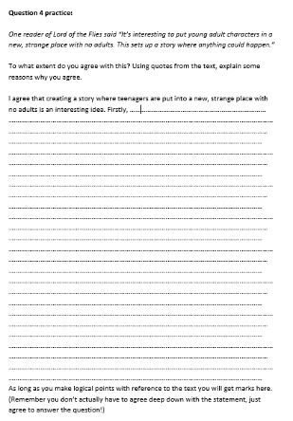

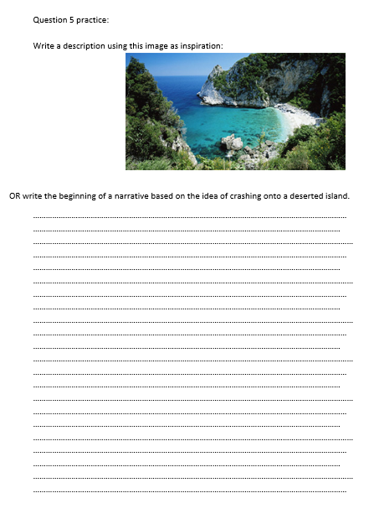
This page had a practice Question 4 – where you agree with the opinion given and, using quotations, say how the text proves that opinion

This page had a practice Question 5 – creative writing! This is the question you should do first, and spend half your time on – and use your best phrases in!

In THIS pack I’ve answered all the 5 questions – at Level 2 standard. I would get 27 marks, a grade 3, for this set of answers. As revision I would like you to improve each of my answers – I need 37 marks for a grade 4.
Your job: improve each answer by 2 marks = a grade 4!

Question 1: Look at the first paragraph and list 4 things about the island location:
1. ……………………………………………………………………………………………………………….
2. ……………………………………………………………………………………………………………..
3. …………………………………………………………………………………………………………………..
4. ……………………………………………………………………………………………………………………..
Question 2: How does the writer use language to present the setting?
You could include the writer’s choice of:

• words and phrases
• language features and techniques
• sentence forms.

………………………………………………………………………………………………………………………………………………………………….
……………………………………………………………………………………………………………………………………………………………………
………………………………………………………………………………………………………………………………………………………………….
………………………………………………………………………………………………………………………………………………………………….
…………………………………………………………………………………………………………………………………………………………………..
………………………………………………………………………………………………………………………………………………………………….
………………………………………………………………………………………………………………………………………………………………..
……………………………………………………………………………………………………………………………………………………………….
………………………………………………………………………………………………………………………………………………………………
………………………………………………………………………………………………………………………………………………………………….
……………………………………………………………………………………………………………………………………………………………………
………………………………………………………………………………………………………………………………………………………………….
………………………………………………………………………………………………………………………………………………………………….
……………………………………………………………………………………………………………………………………………………………………
………………………………………………………………………………………………………………………………………………………………….
………………………………………………………………………………………………………………………………………………………………….
……………………………………………………………………………………………………………………………………………………………………
………………………………………………………………………………………………………………………………………………………………….
………………………………………………………………………………………………………………………………………………………………….
Question 3: How has the writer used structure to interest the reader?
You could write about:
• what the writer focuses your attention on at the beginning
• how and why the writer changes this focus as the extract develops
• any other structural features that interest you.
………………………………………………………………………………………………………………………………………………………………….
……………………………………………………………………………………………………………………………………………………………………
………………………………………………………………………………………………………………………………………………………………….
………………………………………………………………………………………………………………………………………………………………….
…………………………………………………………………………………………………………………………………………………………………..
………………………………………………………………………………………………………………………………………………………………….
………………………………………………………………………………………………………………………………………………………………..
……………………………………………………………………………………………………………………………………………………………….
………………………………………………………………………………………………………………………………………………………………
………………………………………………………………………………………………………………………………………………………………….
……………………………………………………………………………………………………………………………………………………………………
………………………………………………………………………………………………………………………………………………………………….
………………………………………………………………………………………………………………………………………………………………….
……………………………………………………………………………………………………………………………………………………………………
………………………………………………………………………………………………………………………………………………………………….
………………………………………………………………………………………………………………………………………………………………….
……………………………………………………………………………………………………………………………………………………………………
………………………………………………………………………………………………………………………………………………………………….
………………………………………………………………………………………………………………………………………………………………….
……………………………………………………………………………………………………………………………………………………………………
………………………………………………………………………………………………………………………………………………………………….
………………………………………………………………………………………………………………………………………………………………….
……………………………………………………………………………………………………………………………………………………………………
………………………………………………………………………………………………………………………………………………………………….
Question 4: One reader of Lord of the Flies said “It’s interesting to put young adult characters in a new, strange place with no adults. This sets up a story where anything could happen.”
To what extent do you agree with this? Using quotes from the text, explain some reasons why you agree.
………………………………………………………………………………………………………………………………………………………………….
……………………………………………………………………………………………………………………………………………………………………
………………………………………………………………………………………………………………………………………………………………….
………………………………………………………………………………………………………………………………………………………………….
…………………………………………………………………………………………………………………………………………………………………..
………………………………………………………………………………………………………………………………………………………………….
………………………………………………………………………………………………………………………………………………………………..
……………………………………………………………………………………………………………………………………………………………….
………………………………………………………………………………………………………………………………………………………………
………………………………………………………………………………………………………………………………………………………………….
……………………………………………………………………………………………………………………………………………………………………
………………………………………………………………………………………………………………………………………………………………….
………………………………………………………………………………………………………………………………………………………………….
……………………………………………………………………………………………………………………………………………………………………
………………………………………………………………………………………………………………………………………………………………….
………………………………………………………………………………………………………………………………………………………………….
……………………………………………………………………………………………………………………………………………………………………
………………………………………………………………………………………………………………………………………………………………….
………………………………………………………………………………………………………………………………………………………………….
………………………………………………………………………………………………………………………………………………………………….
………………………………………………………………………………………………………………………………………………………………….
……………………………………………………………………………………………………………………………………………………………………
………………………………………………………………………………………………………………………………………………………………….
………………………………………………………………………………………………………………………………………………………………….
Question 5 practice: Write a description using this image as inspiration:
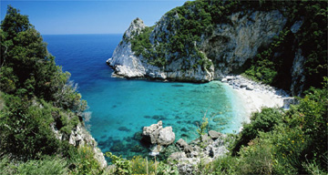

OR write the beginning of a narrative based on the idea of crashing onto a deserted island.
………………………………………………………………………………………………………………………………………………………………….
……………………………………………………………………………………………………………………………………………………………………
………………………………………………………………………………………………………………………………………………………………….
………………………………………………………………………………………………………………………………………………………………….
…………………………………………………………………………………………………………………………………………………………………..
………………………………………………………………………………………………………………………………………………………………….
………………………………………………………………………………………………………………………………………………………………..
……………………………………………………………………………………………………………………………………………………………….
………………………………………………………………………………………………………………………………………………………………
………………………………………………………………………………………………………………………………………………………………….
……………………………………………………………………………………………………………………………………………………………………
………………………………………………………………………………………………………………………………………………………………….
………………………………………………………………………………………………………………………………………………………………….
……………………………………………………………………………………………………………………………………………………………………
………………………………………………………………………………………………………………………………………………………………….
………………………………………………………………………………………………………………………………………………………………….
……………………………………………………………………………………………………………………………………………………………………
………………………………………………………………………………………………………………………………………………………………….
………………………………………………………………………………………………………………………………………………………………….
………………………………………………………………………………………………………………………………………………………………….
……………………………………………………………………………………………………………………………………………………………………
………………………………………………………………………………………………………………………………………………………………….
………………………………………………………………………………………………………………………………………………………………….
…………………………………………………………………………………………………………………………………………………………………..
………………………………………………………………………………………………………………………………………………………………….
………………………………………………………………………………………………………………………………………………………………..
……………………………………………………………………………………………………………………………………………………………….
………………………………………………………………………………………………………………………………………………………………
………………………………………………………………………………………………………………………………………………………………….
……………………………………………………………………………………………………………………………………………………………………
………………………………………………………………………………………………………………………………………………………………….
………………………………………………………………………………………………………………………………………………………………….
……………………………………………………………………………………………………………………………………………………………………
………………………………………………………………………………………………………………………………………………………………….
………………………………………………………………………………………………………………………………………………………………….
……………………………………………………………………………………………………………………………………………………………………
………………………………………………………………………………………………………………………………………………………………….
………………………………………………………………………………………………………………………………………………………………….
………………………………………………………………………………………………………………………………………………………………….
……………………………………………………………………………………………………………………………………………………………………
………………………………………………………………………………………………………………………………………………………………….
………………………………………………………………………………………………………………………………………………………………….
…………………………………………………………………………………………………………………………………………………………………..
………………………………………………………………………………………………………………………………………………………………….
………………………………………………………………………………………………………………………………………………………………..
………………………………………………………………………………………………………………………………………………………………..

