Inserting h2 tag with the Infographic
In the brief it states:

Infographic “The image INFOGRAPHIC.bmp can be found in the IMAGES folder:
• create a box on the home page with the background colour
#0099cc and a 1px solid black border
• add the title – Facts and Figures – using an <h2> tag
• insert the infographic image into the box, beneath the title”

Tip: Remember all images including the info graphic must be the file size required which is less than 250kb. If it is not then you must make it smaller.

Step 1
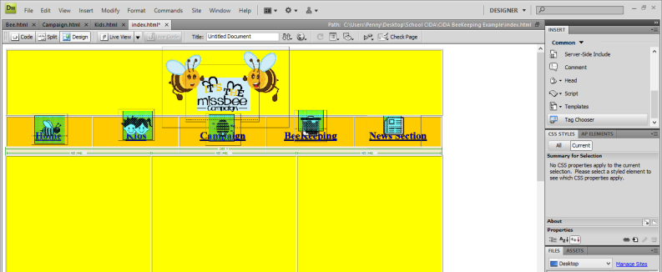
Open up the home page, on the Right hand side Select Tag Chooser

Step 2
This pop up list will appear Select HTML Tags

Step 3
Select h2

This means h2 tags below are examples of each heading tag sizes

Step 4
Fill this section out, Alignment (Meaning where abouts on the page do you want this title, centre, left, right ?)
Header: Type in what you want as the title “ Facts and Figures”

Step 5
Type in the name of the heading

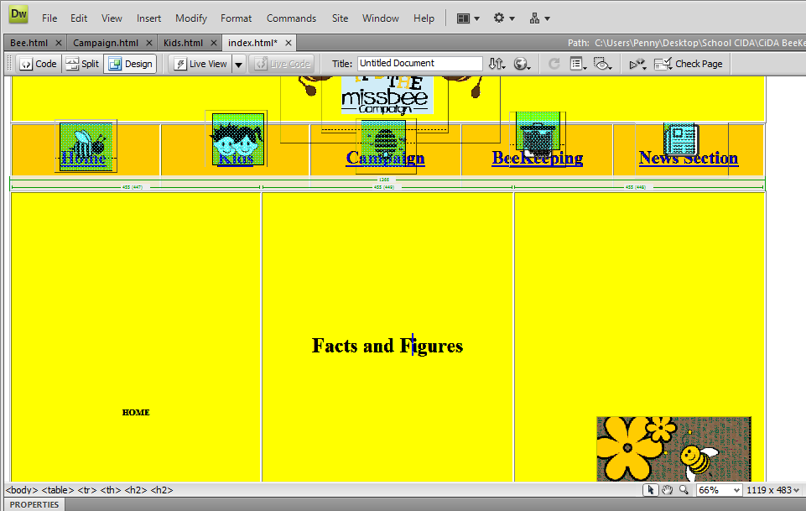
Step 6

Step 7
Under the Title you must add:
Infographic “The image INFOGRAPHIC.bmp can be found in the IMAGES folder:
• create a box on the home page with the background colour
#0099cc and a 1px solid black border

• insert the infographic image into the box, beneath the title”

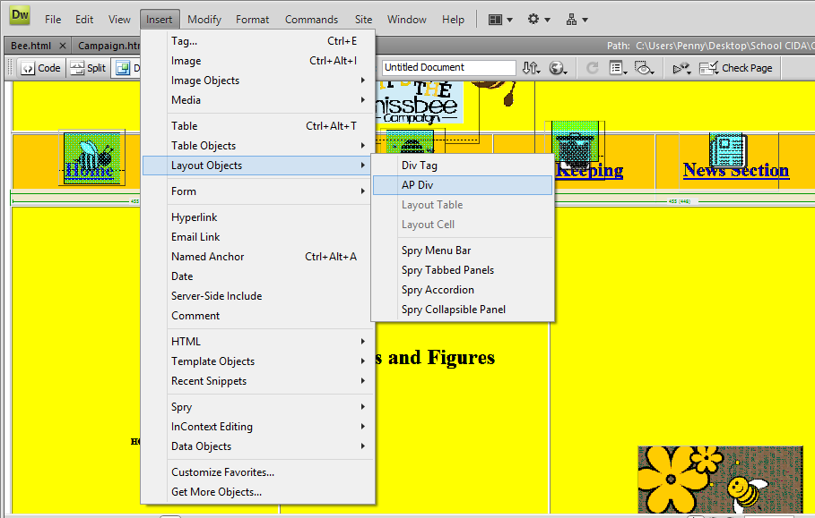
Step 8

To insert a box select Insert >> Layout Object >> AP Div

Step 9
The blue box will appear

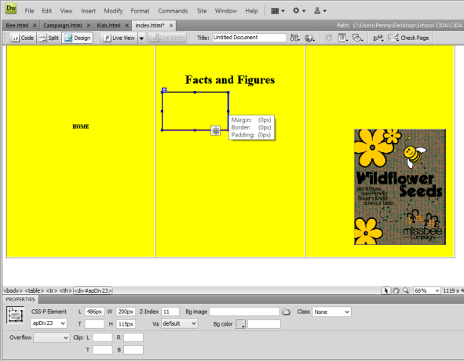
Step 10
“#0099cc and a 1px solid black border” this means the box must be tis colour and have a boarder around it.

To set the background colour, click in the Bg colour bdox and type in the colour requie

Type in #0099cc

“This s the colour requested”
Step 11
The box will change colour

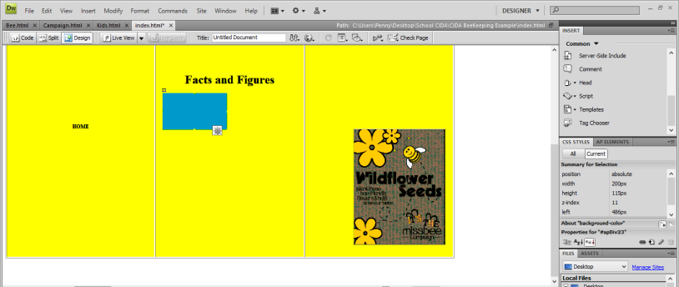
Step 12
Now to add the border, click on the box
The properties will be on the left hand side

Select the icon that looks like pencil
This allows you to edit the properties

Step 13
Select “Border”

Step 14
Top: Select SOLID

Select 1 px

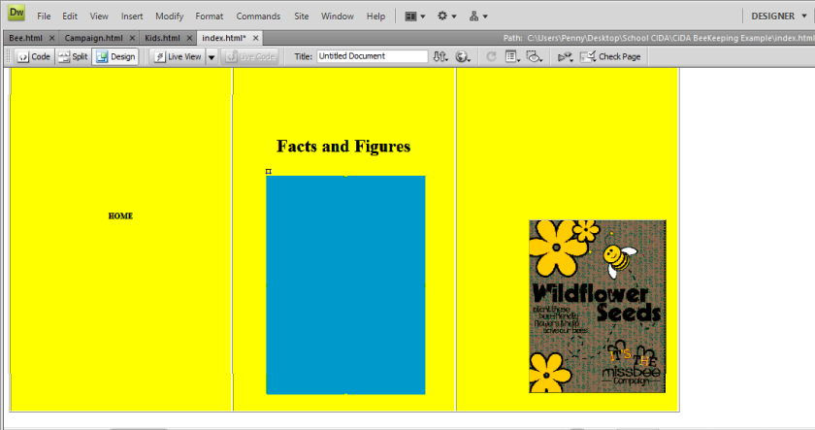
Step 15
Stretch the box so its big enough for the image to fit in

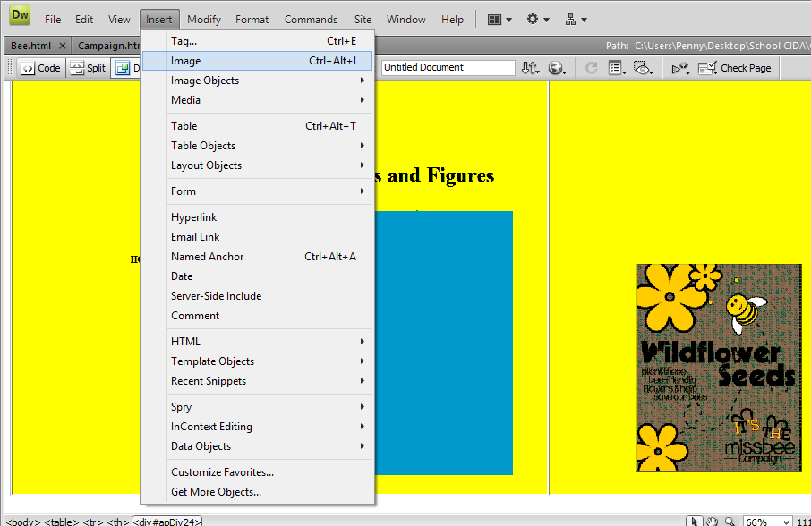
Step 16
Select Insert >> Image

Step 17
Select the image

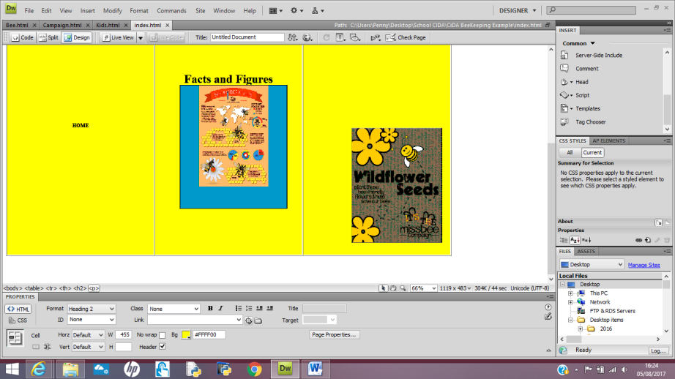
Step 18
Once the image is on the background it must be centred, as you can see it is up the top.

Step 19

The V space and H space will allow you to move the image so you can see the background

