Inserting Sound
Step 1
Open up the page you would like to add the sound too
On the right hand side of the screen select Media Plugin

Step 2
From the pop up box select the Audio file you like to insert

Step 3
The file will appear on the screen, add a AP Div “Blue Box” this will allow you to move the sound around on the page.

Step 4
Drag and drop the sound file into the blue box

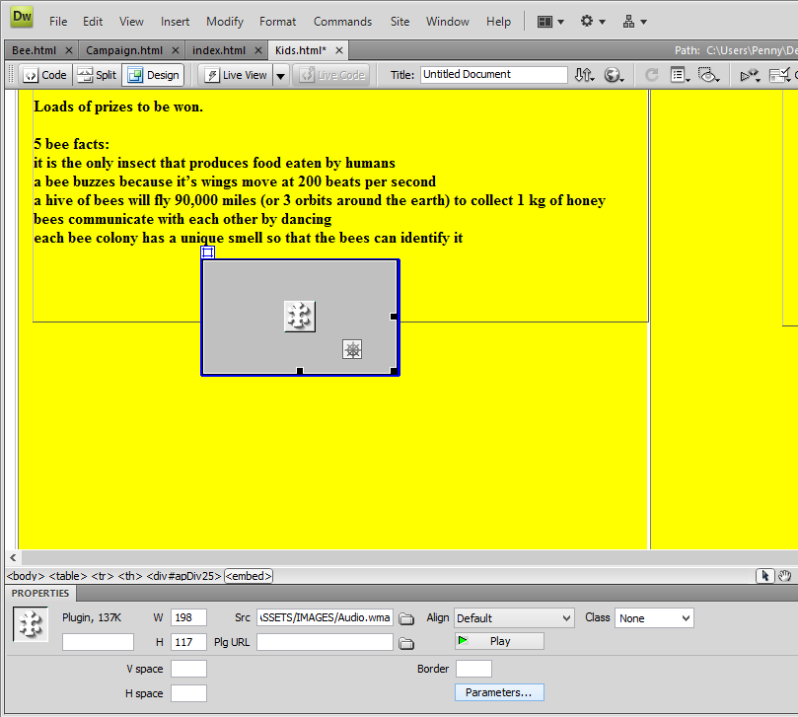
Step 5
Click on the Parameters button

The following box will pop up. These parameters mean Add controllers (For the user to press play, pause, or stop) Do not auto play unless asked to on a exam paper.

