Creating a Banner in Photoshop
Step 1
Open up photoshop and select new
Step 2
In Brief it states that the width of the page should be 1366 so a good idea would be to set the banner width as 1366 pixels as it must go across every page. Another good tip would be to se the height to 200 pixels.
Name it banner
Width: 1366 pixels
Height: 200 pixels
Then click ok

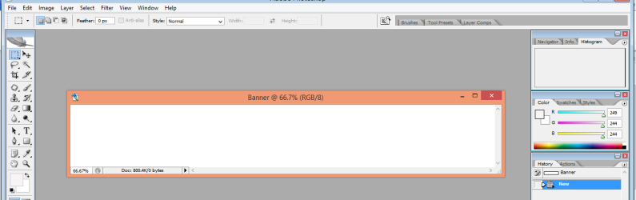
Step 3
The white canvas will appear. Now you must follow what it say on the brief.

“A banner including a suitable image and the company logo. The banner should extend to the full width of the page”
Select File >> Open

The pop up box will appear, find the assests folder and select a suitable image.
Step 4

Once a image is selected use the arrow tool to click and drag the image onto the Banner (Canvas) behind.

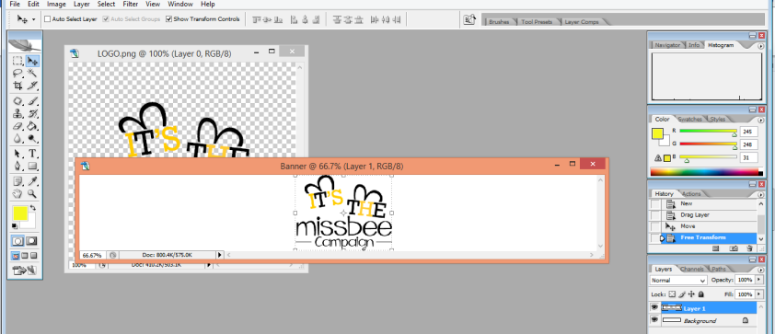
Step 5

You can Edit the image by double clicking on the layer

The pop up box appears, you can select some of the options

You can guve you banner colour, remember this colour must match your colour scheme and will stay consistent on every page.

Step 6
Select the colour of your choice

Then select the bucket tool and click on the canvas

Now save the banner

