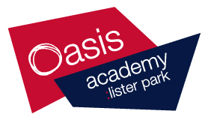**Welcome to**

**A-Level Religious Studies**

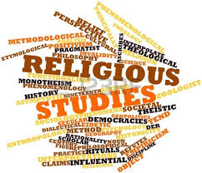

Well done for considering taking Religious Studies A-Level.

This pack contains activities and resources to prepare you to start for A Level Religious Studies in September. Everyone must have this pack completed for the first lesson. It is aimed that you start this after you get your GCSE results, to ensure you are well prepared to commence in September.

The pack will introduce you to some of the key information that is needed to succeed in Religious Studies and topics you will study. You will need to complete this booklet and have it in your folder at the start of the year.

We currently study the ORC Religious Studies specification. Here is a link that will take you to it so you can have an in-depth look at what you will be studying: <https://ocr.org.uk/qualifications/as-and-a-level/religious-studies-h173-h573-from-2016/#as-level>

**Did you know that although the course is called ‘Religious Studies’ it is actually split into 3 different topics; 1.Philosophy, 2.Ethics & 3.Religious studies.**

**What do I need to study this course?**

A level Philosophy, Ethics & Religious Studies is suitable for students with an open and enquiring mind, who are willing to develop extended reading and writing skills, and who enjoy engaging with the big and challenging questions of life, such as: Is there a God? What is a moral action? Students wishing to enrol on the subject must have at least a grade 4 in GCSE English, Maths and RE.

**What will I study?**

**Paper1 - Philosophy of Religion** – You will begin with the basis of all philosophy: the Greek scholars Plato and Aristotle. From there you will explore the arguments and evidence for and against the existence of God, the problem of evil, whether humans have a soul, what God is like, and whether God can be found in religious experiences or spoken about at all.

**Paper 2 - Ethics** – You will explore different theories about how to be moral (both religious and secular), along with their practical application to issues such as euthanasia, business, and sexual ethics. Ideas surrounding the existence of a conscience will be considered as well as evaluating whether ethics is just a matter of opinion.

**Paper 3 - Development in Christian Thought** – This strand looks at how Christianity has developed over the centuries, from an exploration of the nature of Jesus, to arguments surrounding how Christian thought has developed and impacted society, both in the past and present. How should a Christian challenge dictatorships such as Hitler’s or those in South America in the 20th century? You will also consider the influence of feminism on society and religion, as well as the role of other faiths and secular thought in contemporary society.

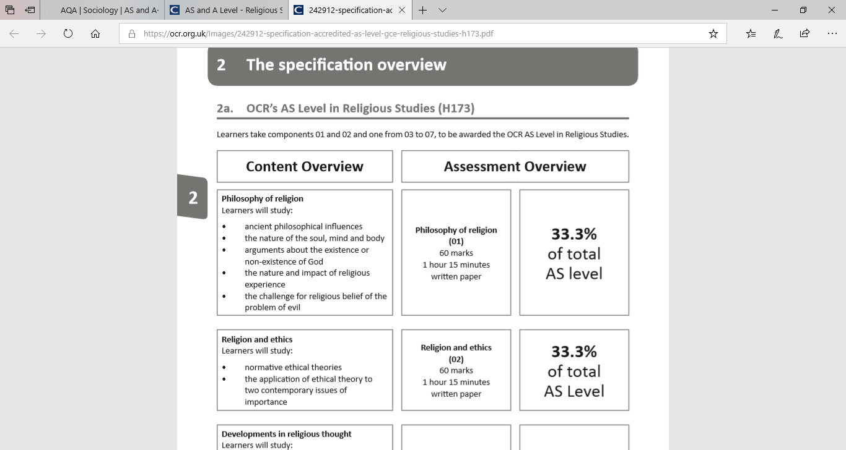**These three strands will be examined in three separate, equally weighted exams at the end of each year of the course. AS overview below;**

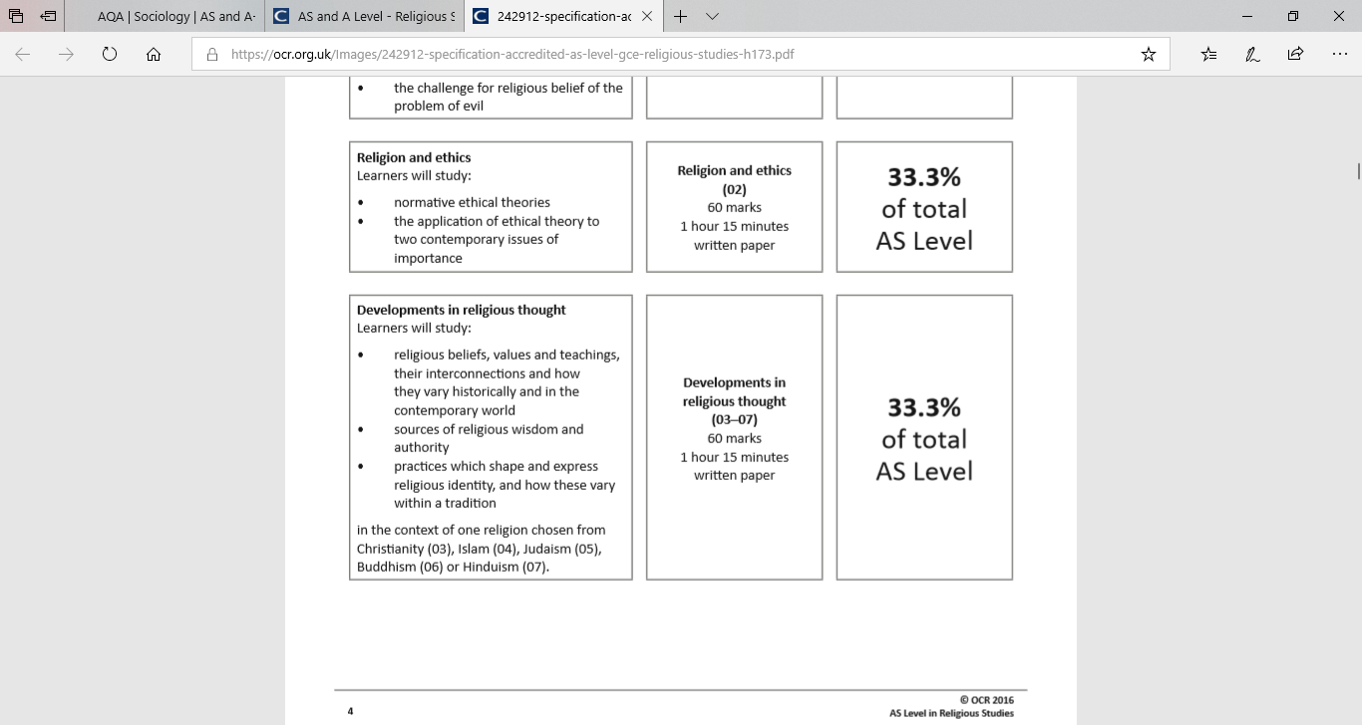

***We have high expectations of our students in Religious education and hold students to these expectations. We want you to succeed in******Religious education and therefore it is essential you follow the Post 16 Code of conduct and adhere to the departments expectations as follows:***

**• 100% attendance is vital to ensure you succeed in** **Religious education. We expect students to attend all lessons of Religious education. If you are absent for any reason then it is your responsibility to come and ask for any work that you have missed on your return. If you anticipate being absent for a lesson, you must inform the subject teacher who will provide you with work to complete.**

**• Punctuality – We expect students to arrive on time, fully equipped every lesson.**

**• Homework and wider reading. Homework in the form of essays and extended questions will be set every week. This must be completed to the best of your ability.**

**• Revision – There will be regular mini exams to test your knowledge and extended writing skills. It is crucial that you revise for these tests.**

**• Organisation – The final page of this booklet outlines what you need to bring. Ensure your file is brought to every lesson and all your notes, task sheets, exam papers are neatly placed in your folder with the appropriate dividers. This will be monitored on a regular basis.**

**• Independent study – We expect our students to take part in wider reading of the content. This will include suggested readings alongside guided independent study activities which need to be completed in your subject allocated independent time.**

**• 100% commitment to the course. A-levels require 100% dedication to the subject they are much harder than GCSE’s. You are expected to work hard both in class and at home to ensure that you succeed and that all tasks are completed to the best of your ability.**

**Reading list for A Level Religious studies**

**There are some books listed at the bottom of each section on the specification, here’s the link to access this:**

[**https://ocr.org.uk/Images/242912-specification-accredited-as-level-gce-religious-studies-h173.pdf**](https://ocr.org.uk/Images/242912-specification-accredited-as-level-gce-religious-studies-h173.pdf)

**Text books you will need;**

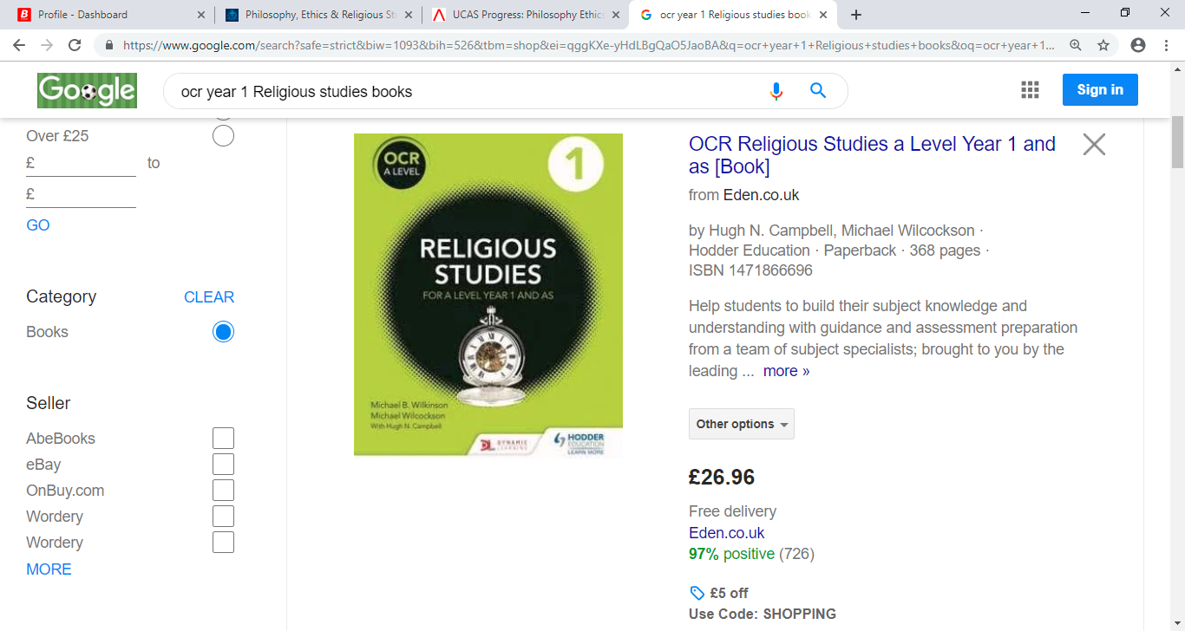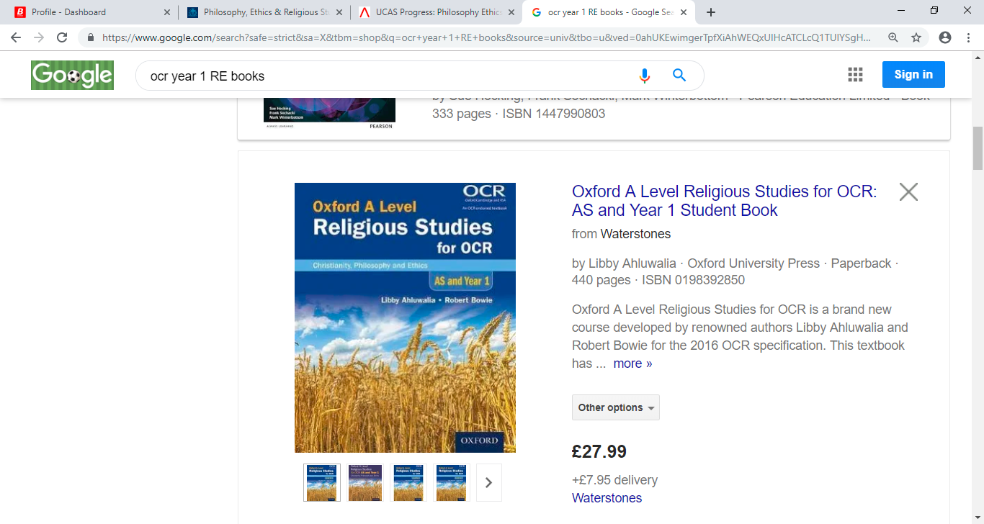**AS Year 1 -**

£27.99 £26.96

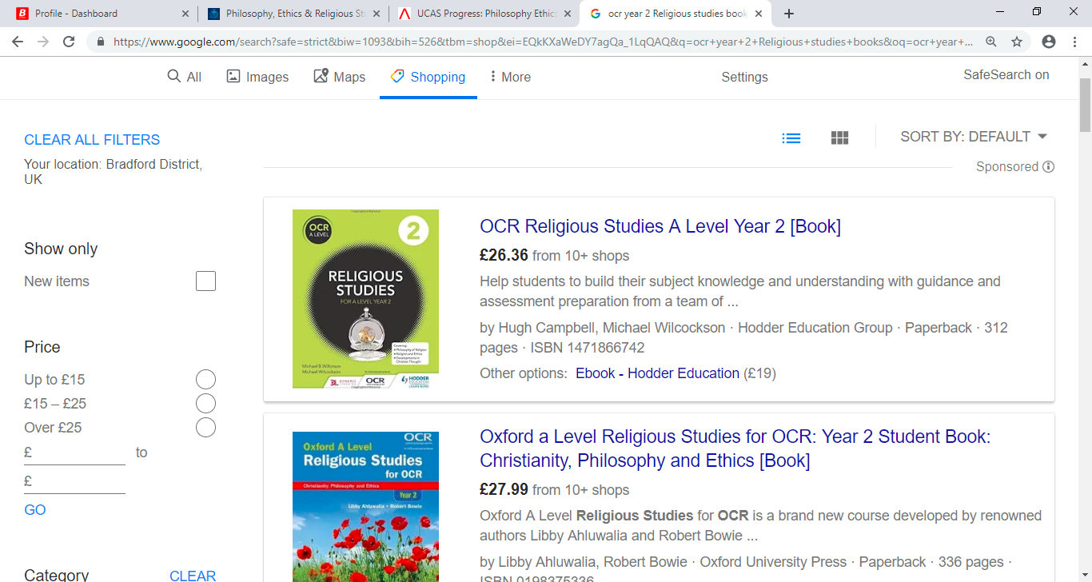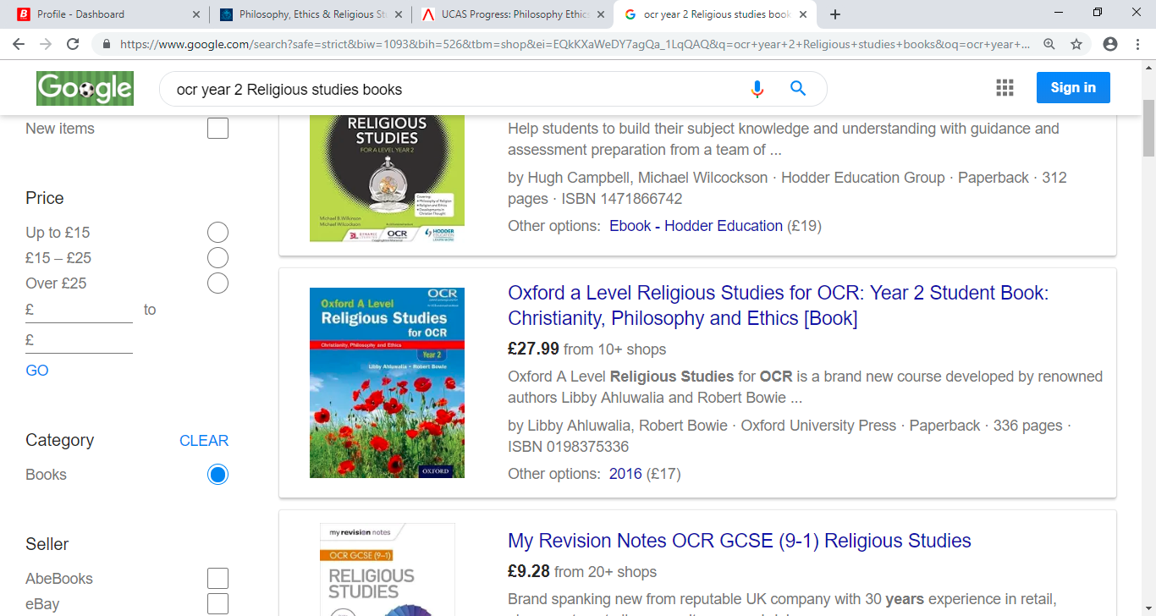**A2 Year 2 –**

£26.36 £27.99

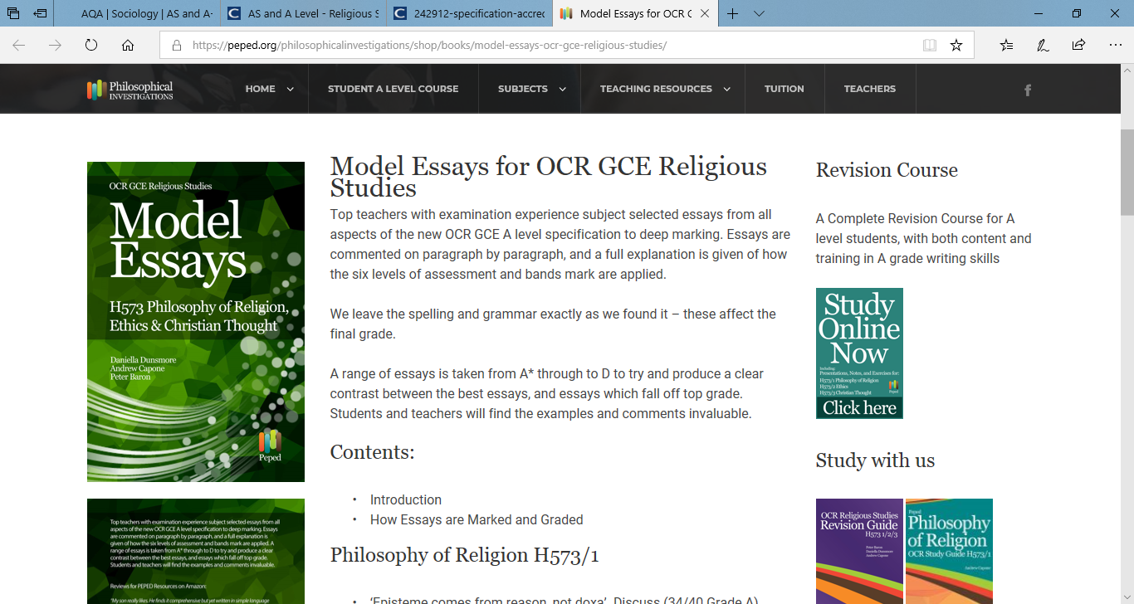**For all exams you will have to write essays, 2 essays per paper, that equates to 6 essays to write for your AS exam.**

**To get a head start and become an essay writing pro, you can purchase this book for £8.81 from amazon.**

**Skills?** You will acquire a large number of highly valuable transferable skills that are useful for both university and the workplace. We as teachers will encourage you to develop an open mind: to think clearly, analyse evidence, and argue effectively in writing, as well as supporting you to gain a crucial insight into important aspects of modern society.

**What next?**

Religious studies is highly regarded as an entry qualification for higher education courses; it is a hinge subject which sits comfortably with sciences, arts and humanities, providing perspective and support to all forms of study. Its analytical approach nurtures skills that are prized by both universities and employers, including innovative thinking, clarity of thought, and communication skills. This A level also fosters the writing and research skills that are the bedrock for all degree courses and wider employment opportunities. It is considered a valuable area of study in a number of different fields that rely on an ethical or philosophical perspective.

Oasis Academy students have gone on to study at a wide range of universities including Cambridge, Bristol, Birmingham, Liverpool, Newcastle, Nottingham, Leuven in Belgium, Sheffield, Leeds, UCL, and King’s College London. Students have pursued occupations as varied as medicine, teaching, politics, law, journalism, economics, finance, marketing and business.



According to some estimates, there are roughly 4,200 religions in the world.

Tasks that must be completed for your first lesson in September…

**Task 1: Research into Philosophy**

Read these instructions carefully! You need to watch the following video and make notes on the content.

I strongly suggest you watch the video at least twice. Once just watching it then a second time regularly stopping it to take notes:

<https://www.youtube.com/watch?v=1A_CAkYt3GY> - (What is Philosophy?: Crash Course Philosophy #1)

**Task 2: Introduction into key ethical theories of Year 1 content** (Check spec for this info!)

Religious studies is a research-based subject. We look at different perspectives and ethical theories to help us explain how things work. For this task you can research any two theories from the spec that interest you.

Your task is to research;

* 5 main points about this theory
* How they work in society
* key ideas
* Key words
* Include points as to why someone would say this theory does not work

**Task 3: Development in Christian thought**

As a Religious Studies student, it is crucial that you are aware of what is happening in society and how it can link to key ideas within Christianity. Therefore you need to be able to discuss and write assignments and debates on various issues.

Your task is to **debate whether Christianity is the correct way to live in the modern era**. In your answer you should include;

1. Arguments FOR the statement
2. Arguments AGAINST the statement
3. Justified conclusion

For your first lesson…

Organisation and Preparation is key to success

We expect you to have the following:

1) A level arched folder – labelled with your name on and Religious studies

2) There must be dividers in your folder

3) Your own lined paper

4) Plenty of plastic wallets.

5) A pencil case with the usual but we use a lot of highlighters so have plenty of those.

6) The welcome pack at the front of the folder

7) Your homework task that are in this booklet preferably typed up and in separate plastic wallets.

**Well done! You’re all set ready to embark on your Religious Studies A-Level course. We look forward to seeing you in September!**