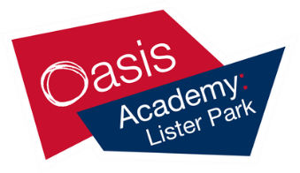
History A Level Summer Preparation Task

Part 1 – The Tudors

Purpose of task:
One of the biggest challenges with studying 17th Century History is having the background knowledge about how government worked and what life was like in this period of time. The below activities are designed to enable you to gain this essential background knowledge.

Task: British History
Compulsory Task 1: Background Research Task
Please make notes on the following issues. Aim to write about three to four pages in total. Please present all of your work in your own handwriting and own words.

Henry VIII
1. What reasons did Henry VIII have for wanting to change the English Church from
Catholic to Protestant?
2. The three monarchs after Henry VIII were: Edward VI, Mary I, Elizabeth I. How did each of them change the English Church?

Elizabeth I
3. Make a list of powers Elizabeth I had when she was Queen of England (e.g. she could choose her own advisors/ ministers)[Search: Elizabethan Government]
4. Make a list of problems Elizabeth I had as Queen of England. Which ones didn’t
she solve?

James VI and I
5. What relation was James VI of Scotland to Elizabeth I of England? Why did he become king in 1603?
6. What was the relationship between England and Scotland like in the 16th century?

Life in Early Modern England
7. What different ranks / classes in society were there? What jobs did people do? [Search: Life in Stuart England]
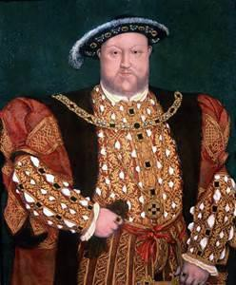8. What were the main differences between life in the seventeenth century and now?
Recommended resources:

As this is likely to be an unfamiliar period to you it will be helpful for you to start by reading things that are more accessible and then working your way up. Some ideas for accessible books are:

Horrible Histories: The Slimy
Stuarts by
Terry Deary – an amusing
guide to the whole century

Phillipa Gregory writes historical fiction based around this time period. ‘The White Queen’,
‘The Red Queen’ or ‘The Kingmaker’s Daughter’ are recommended. The White
Queen is also available as a dramatisaton.

Useful Websites include: http://spartacus- educational.com/

https://schoolhistory.co.uk/alev el/earlymodern_british.shtml

http://www.earlymodernenglan d.com/

Compulsory Task 2: Key term definitions
On a separate piece of paper write down a list of definitions for the following words: PARLIAMENT ROYAL COURT
PRIVY COUNCIL DIVINE RIGHT OF KINGS FEUDAL SYSTEM JUSTICE OF THE PEACE (JP) PATRONAGE FACTION
MILITIA REFORMATION PROTESTANT EPISCOPACY

This will form the beginning of your key term glossary which you will continue to add to throughout the course.

Deadline for Task: First lesson in week commencing 11th September 2017

Additional information:

Recommended reading & activities list:

One of the key differences between GCSE and A Level is the expectation that you will carry out your own independent wider reading throughout the course. The more background reading you do, the better prepared you will be. Below is a list of some introductory texts which will give you a good background to the period we will be studying:

J Morrill, Stuart Britain: A Very Short Introduction, Oxford University Press, 2000

K Brice, The Early Stuarts, 1603-1640, Hodder Murray, 1994

M Bennett, The English Civil War, Longman, 1995

C Durston, James I, Routledge, 1993

Wider reading does NOT mean you have to read all of these books from cover to cover. Use the contents and index pages to find and read the relevant sections. A full list of useful books will be given to you in September.

