24th January 2023

Dear parent/carer,

Re: Year 7 Trip to Leeds Armouries – Ancient Greek Myths – Friday 10th February

The English Department of Oasis Academy Lister Park are planning a visit to Leeds Armouries for x30 Year 7 students to be a part of an ‘Ancient Greek Myths’ workshop. This term, students have been studying the art of storytelling. This trip will provide students with the opportunity to develop their own writing skills whilst also consolidating previous knowledge of the Greek myths.

The details are as follows:

Venue: Leeds Armouries, Leeds
Transport: Transport will be arranged to and from the museum.
Departure time from the academy: 11.00am
Return to the academy: 3.00pm

Tickets are available to students at a price of £17.00 and are available for purchase through the MCAS app (please find attached the MCAS user information and guidance).
If you wish your son/daughter to participate, please click on the link below and complete the form.

https://forms.office.com/Pages/ResponsePage.aspx?id=zz3XjXy17EC3-HVbUS2fe8TErHbADVBIlOZ1e2iiHDdUOTdPRVZaOTUwMDVMRUc4S0pFVjhRRkU4NC4u

Yours faithfully,

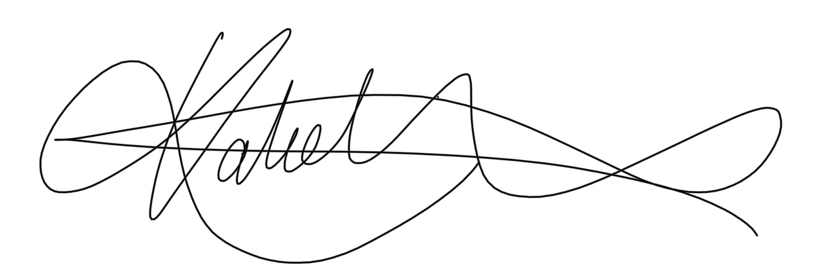

Miss K Houston

Teacher of English

