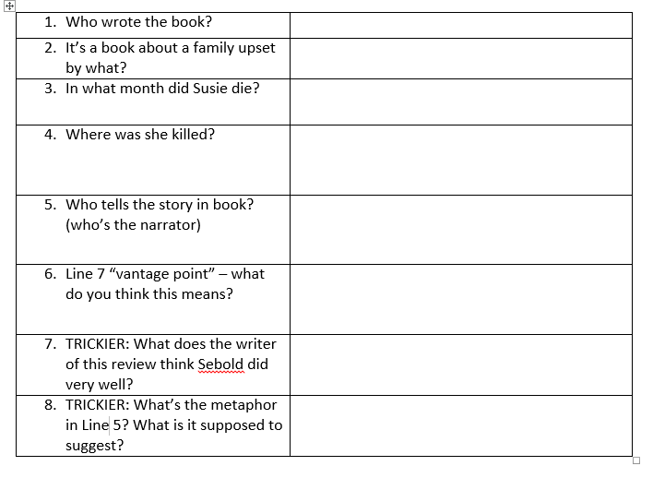
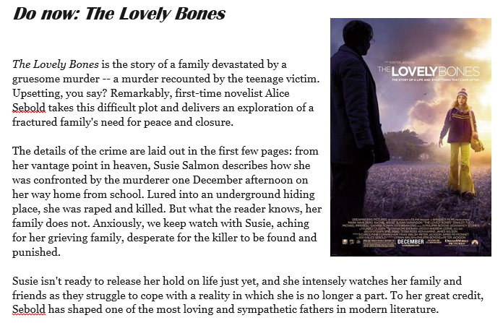
My name was Salmon, like the fish; first name, Susie. I was fourteen when I was murdered on December 6, 1973. In newspaper photos of missing girls from the seventies, most looked like me: white girls with mousy brown hair. This was before kids of all races and genders started appearing on milk cartons or in the daily mail. It was still back when people believed things like that didn't happen.
In my junior high yearbook I had a quote from a Spanish poet my sister had turned me on to, Juan Ram'n Jim'nez. It went like this: "If they give you ruled paper, write the other way." I chose it both because it expressed my contempt for my structured surroundings ' la the classroom and because, not being some dopey quote from a rock group, I thought it marked me as literary. I was a member of the Chess Club and Chem Club and burned everything I tried to make in Mrs. Delminico's home ec class. My favourite teacher was Mr. Botte, who taught biology and liked to animate the frogs and crawfish we had to dissect by making them dance in their waxed pans.
I wasn't killed by Mr. Botte, by the way. Don't think every person you're going to meet in here is suspect. That's the problem. You never know. Mr. Botte came to my memorial (as, may I add, did almost the entire junior high school-I was never so popular) and cried quite a bit. He had a sick kid. We all knew this, so when he laughed at his own jokes, which were rusty way before I had him, we laughed too, forcing it sometimes just to make him happy. His daughter died a year and a half after I did. She had leukemia, but I never saw her in my heaven.
Can you identify the word type, sentence type or other feature in each example?
Tip 1: Use your glossary card to help you!
Tip 2: find the word/quote in the text to help you identify what it is
Mr Botte Mrs Delminico
mousy brown
Killed, murdered
Salmon Susie
Marked
, not being some dopey quote from a rock group,
That's the problem. You never know
Frogs
Problem

Question 2 practice: My name was Salmon, like the fish; first name, Susie. I was fourteen when I was murdered on December 6, 1973. In newspaper photos of missing girls from the seventies, most looked like me: white girls with mousy brown hair. This was before kids of all races and genders started appearing on milk cartons or in the daily mail. It was still back when people believed things like that didn't happen.
In my junior high yearbook I had a quote from a Spanish poet my sister had turned me on to, Juan Ram'n Jim'nez. It went like this: "If they give you ruled paper, write the other way." I chose it both because it expressed my contempt for my structured surroundings ' la the classroom and because, not being some dopey quote from a rock group, I thought it marked me as literary. I was a member of the Chess Club and Chem Club and burned everything I tried to make in Mrs. Delminico's home ec class. My favourite teacher was Mr. Botte, who taught biology and liked to animate the frogs and crawfish we had to dissect by making them dance in their waxed pans.
I wasn't killed by Mr. Botte, by the way. Don't think every person you're going to meet in here is suspect. That's the problem. You never know. Mr. Botte came to my memorial (as, may I add, did almost the entire junior high school-I was never so popular) and cried quite a bit. He had a sick kid. We all knew this, so when he laughed at his own jokes, which were rusty way before I had him, we laughed too, forcing it sometimes just to make him happy. His daughter died a year and a half after I did. She had leukemia, but I never saw her in my heaven.
2. Look at the 2nd paragraph and list 4 things about Susie:
1. ……………………………………………………………………………………………………………….
2. ……………………………………………………………………………………………………………..
3. …………………………………………………………………………………………………………………..
4. ……………………………………………………………………………………………………………………..
3. Look at lines 1 – 13 and think carefully – how does Susie come across to you? Which adjectives could you use to describe her? ……………………………………………………………………………
Is she likeable – would you/most people like her? Yes, no, why? ………………………………………..
. ………………………………………………………………………………………………………………………………………….
Does she sound like a typical teenager? Yes, no, why? ………………………………………………………..
………………………………………………………………………………………………………………………………………………
Does she sound like a typical teenager? Yes, no, why? ………………………………...........................
……………………………………………………………………………………………………………………………………………..
Does she have anything in common with you? ……………………………………………………………………
Does she sound like she deserves to be murdered? ………………………………………………

Question 2 example: How does the writer use language to present Susie to us?
Please read my Level 2 answer – this would be awarded 3 marks (out of 8):
The writer presents Susie as intelligent and happily studious. She mentions two teachers “Mrs Delminico” and “Mr Botte.” The sophisticated words in the extract also show Susie is intelligent “expressed my contempt for my structured surroundings” and “not being a quote from a dopey rock group” are in the same sentence. These details give hints of Susie’s personality.
This is what the answer is missing to raise it to Level 3, worth 5-6 marks:
Terminology to add: (abstract) nouns complex sentence proper nouns adjectives
LO (This suggests…) bits to add and complete:
Susie’s teachers were important to her because….
Susie is deliberately and somewhat showily trying to separate herself from other students by…..
Reader response bit to add and complete:
…..make me feel sorrier that she was “murdered” because…..

Can you re-write and extend my answer, adding and completing the missing parts?
………………………………………………………………………………………………………………………………………………………………….
……………………………………………………………………………………………………………………………………………………………………
………………………………………………………………………………………………………………………………………………………………….
………………………………………………………………………………………………………………………………………………………………….
…………………………………………………………………………………………………………………………………………………………………..
………………………………………………………………………………………………………………………………………………………………….
………………………………………………………………………………………………………………………………………………………………..
……………………………………………………………………………………………………………………………………………………………….
………………………………………………………………………………………………………………………………………………………………
………………………………………………………………………………………………………………………………………………………………….
……………………………………………………………………………………………………………………………………………………………………
………………………………………………………………………………………………………………………………………………………………….
………………………………………………………………………………………………………………………………………………………………….
……………………………………………………………………………………………………………………………………………………………………
………………………………………………………………………………………………………………………………………………………………….
This is the Level 3, 6 mark, answer as I would write it – how similar are yours and my attempts? Highlight any parts of yours and my answers that are the same/similar.
The writer presents Susie as intelligent and happily studious. She mentions two teachers “Mrs Delminico” and “Mr Botte” and these proper nouns suggest Susie’s teachers were important to her because she mentions them by name and there are no students named in the extract. The sophisticated vocabulary and complex sentences also show Susie is intelligent “expressed my contempt for my structured surroundings” and “not being a quote from a dopey rock group” are in the same complex sentence and could suggest that Susie is deliberately and somewhat showily trying to separate herself from other students by using mature expressions about herself, but simple and informal adjectives about other students – “dopey.” These details that give hints of Susie’s personality make me feel more sorry that she was “murdered” because it’s almost as if she’s trying to impress me or make a good impression on me, even though it’s too late.

Self-evaluation:
Did you add in the terminology in the right places, the same as me?
Did you make a “this suggest…” (LO) that made sense with the quote?
Did you add a “this makes me feel/understand/imagine/wonder” about Susie (QR)?

What part of this activity did you find trickiest? (This will tell me which part of the question to help you with until you are confident!)

