Wrapping Text Around A Image

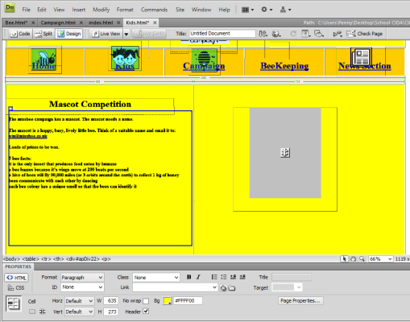
Step 1
Place the cursor at the top of the text before the first word.

Step 2
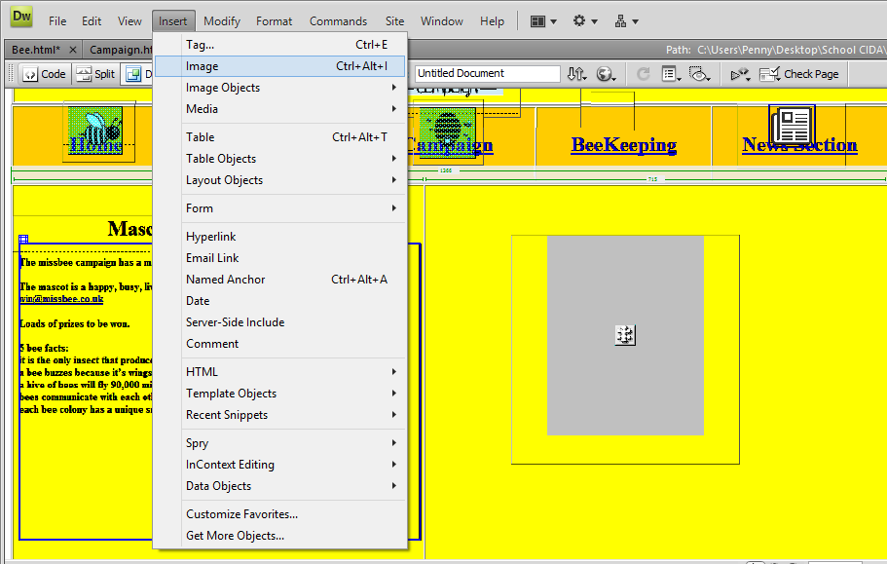
Select Insert >> Image

Step 3
Select your image

Step 4

Click ok

Step 5
Select Align

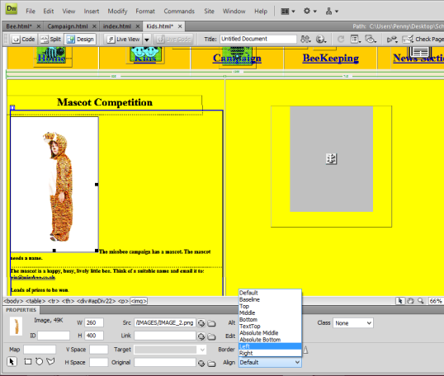
Step 6
Select Left or the side you like the the text to wrap around. The text will then wrap its self around the image

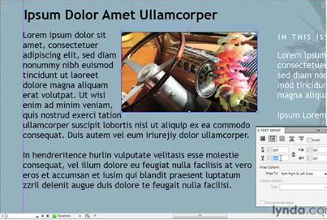
Text Wrapped to the LEFT Text Wrapped to the RIGHT

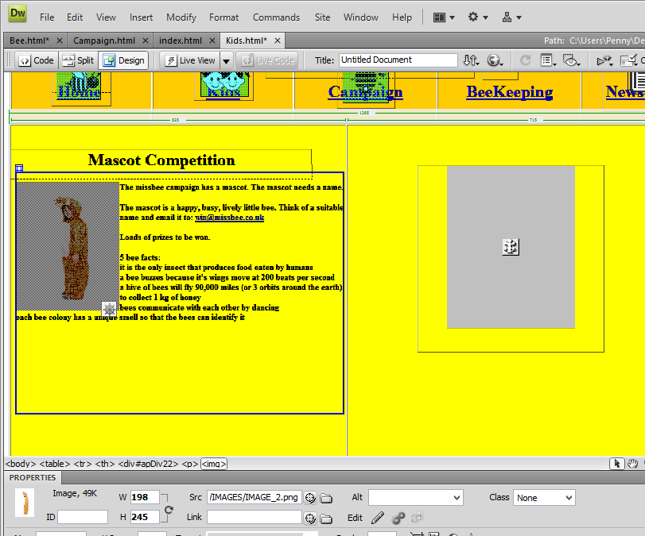
Step 7
You can resize the image by dragging the edges

