Reducing the file size of an Image
Tip: Quick way to check the file size of an image is to roll your mouse over it in the folder. Open up the folder and all the images will be displayed roll your mouse over the image and the properties will appear.
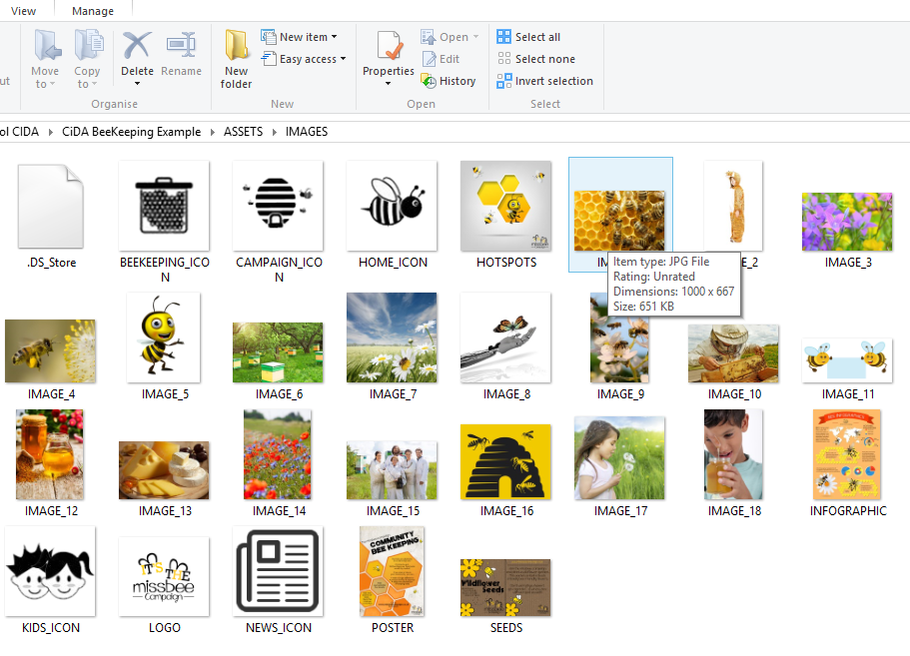

Step 1
Open up Photoshop software and select File >> Open

Click on you assets folder and find the image you would like to reduce the file size of and click Open

The image will open up
Step 2
Select Image >> Image size
Step 3
Changing the width of the image reduces the file the file size.

You will see the file size getting smaller at the top. Click ok

Tip: Don’t forget to check the brief to see what file size is needed.

You will notice that your image has shrunk

Step 4
Select File>> Save for Web

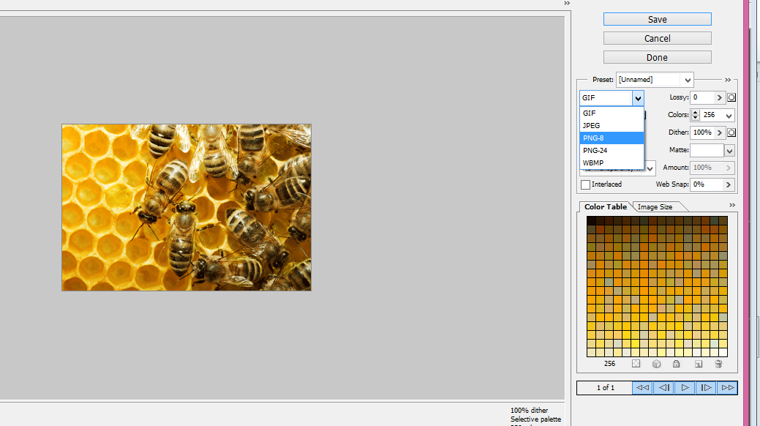
These options allow you to choose the type of file format
Tip: The client brief states all images must be PNG format. Don’t forget to add RE-SIZED at the end of the image name so you know which one you re sized

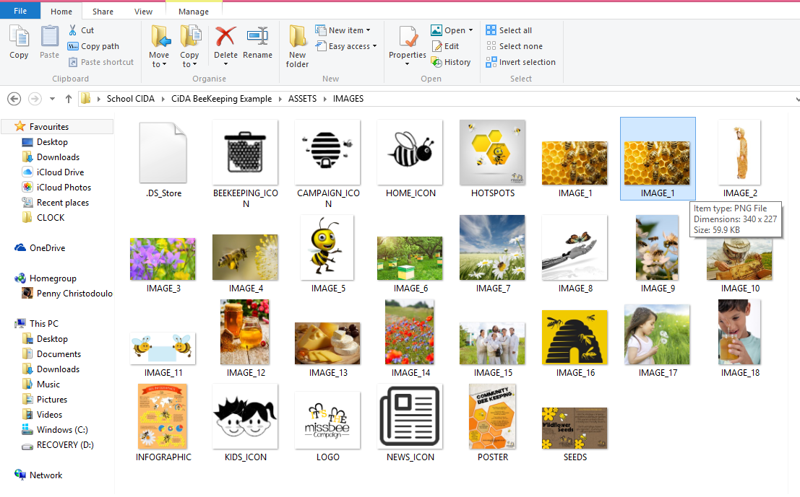
Once you have selected PNG format and clicked save, open up the folder where you have saved the image and see how the image as been reduced.

