Creating Hyperlinks/Buttons in your navigation bar
Tip: Before you start you must know how many buttons/hyperlinks you need in your navigation bar. You must also think about where you would like to place your navigation bar. Across the top or down the left hand side?

For navigation bar on the LEFT hand side start with step 1, for navigation bar across the top go to step 2
Step 1
Once you know how many Hyperlinks you need and where you would like to place your navigation bar you can begin. Select Insert >> table
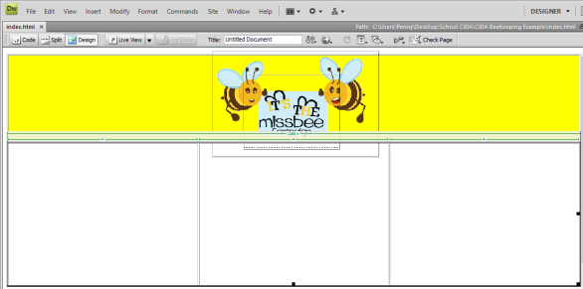

Go To STEP 3 to continue

Step 2
For navigation bar on the ACROSS the top
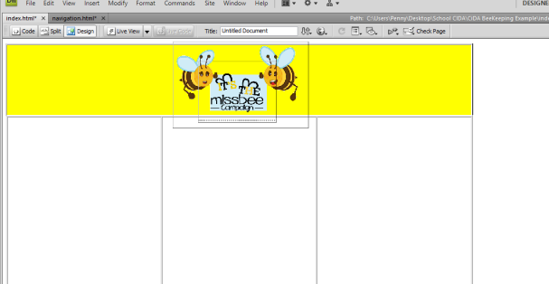
To place the hyperlink/buttons ACROSS the top click on the outside of the banner, once you see the curser flashing select Insert>> Table
Type in 4 columns

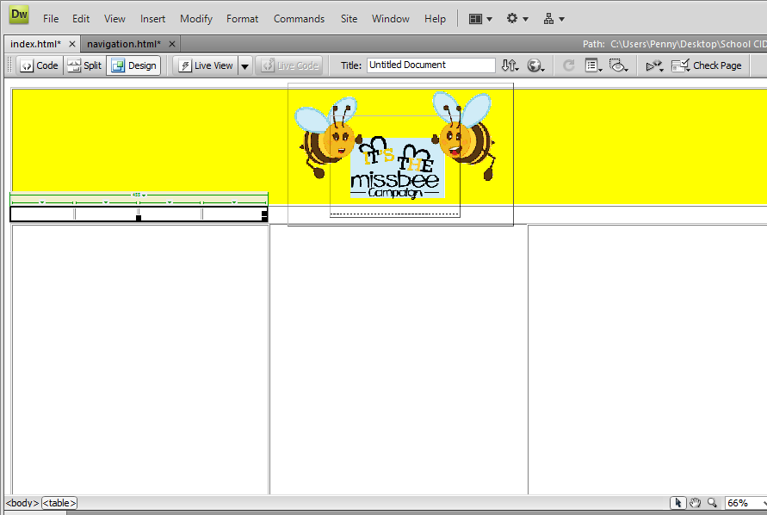
The columns will appear

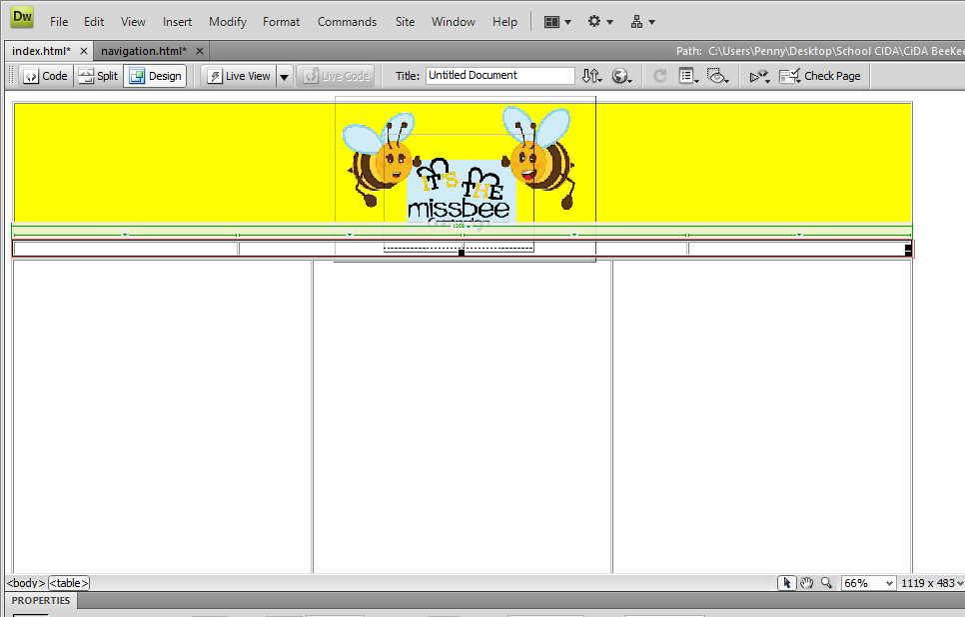
Stretch the columns out across the bottom of the banner

Now go to step 9

Step 3
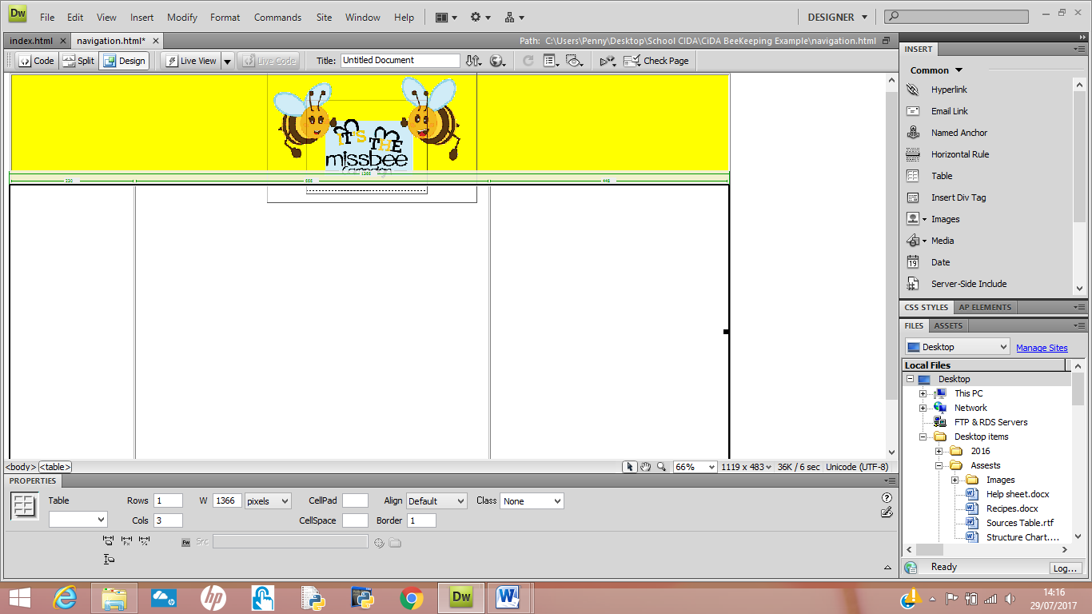
Drag the second line to the left
In this column you will place your buttons.

Step 4
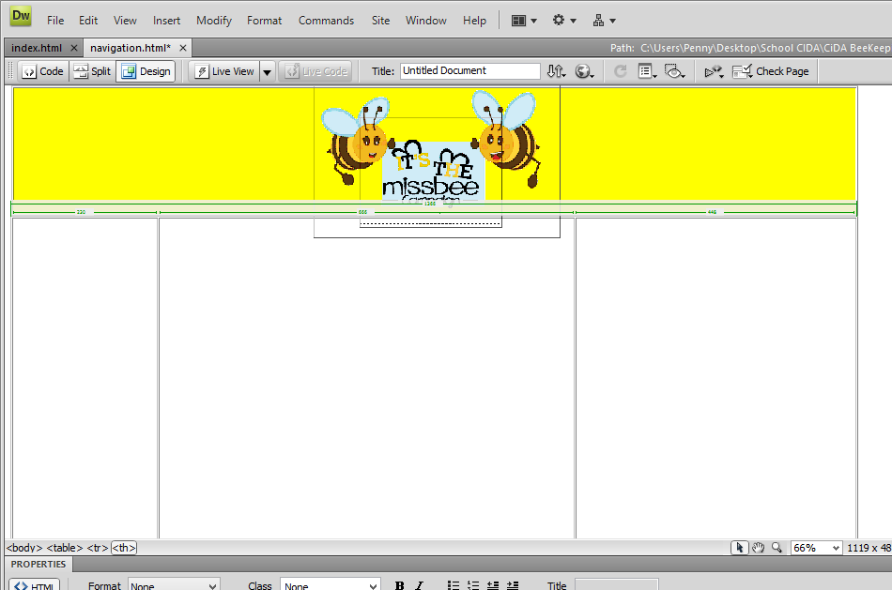
In the brief it states “A navigation bar linking to: the home page including news section, kids page, campaign page linking to the bee keeping page” This means 4 pages are needed as the news section is not a page it is a SECTION.
Click in the left column

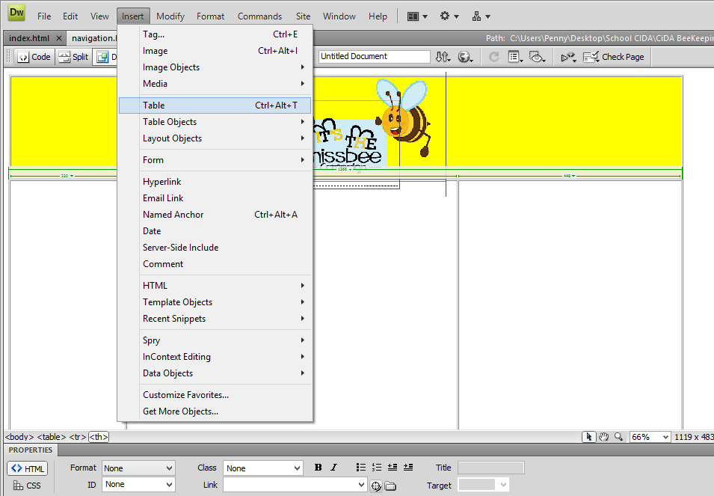
Step 5

Select Insert>>Table

Step 6
Enter 4 in the rows section and 0 in the columns

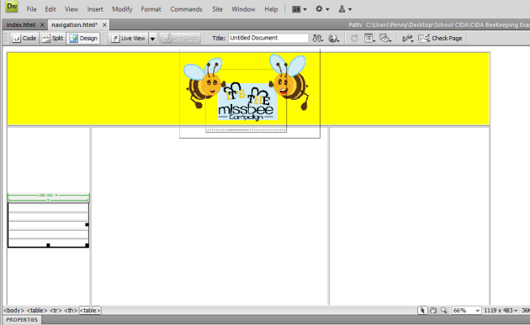
Step 7
4 rows will appear in the left hand column

Step 8
Use your mouse to stretch the rows down to fill the whole of the column

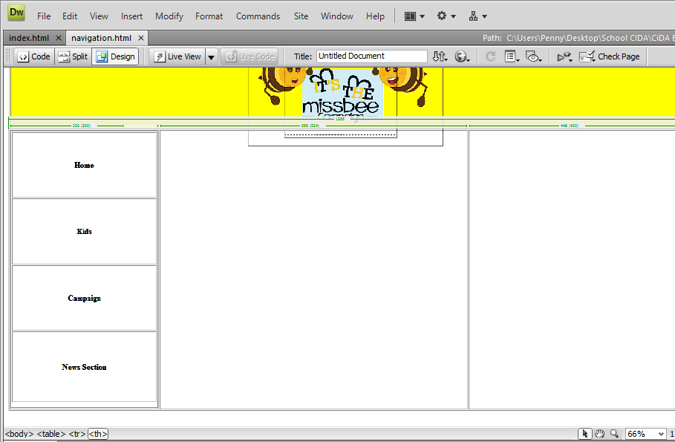
Step 9
Now type in the names of the pages

Step 10

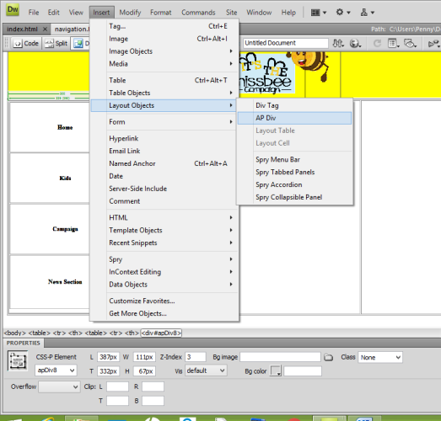
The brief states to use the icons provided. Click in the first box and inset the home icon.
Select Insert>>Layout Object>>AP Div

A blue box will appear

Step 11
You can insert the home icon into the blue box

Step 12
Make sure you have selected your assets folder. Select the home ICON

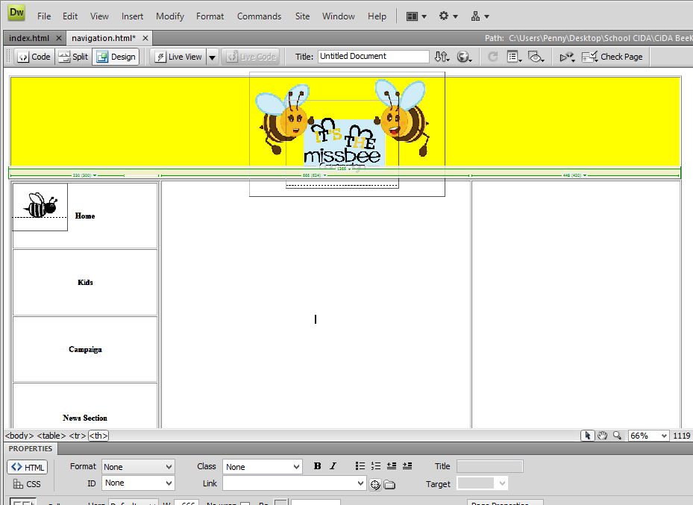
Step 13
Place the image in the box

Tip: View website in explorer by pressing F12
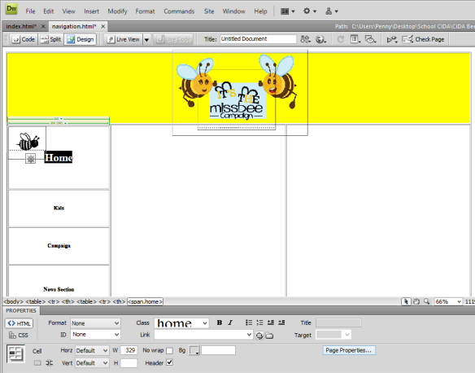
Once all the page names and images have been inserted you can change the font style and colour.
Highlight the text

Then select page properties

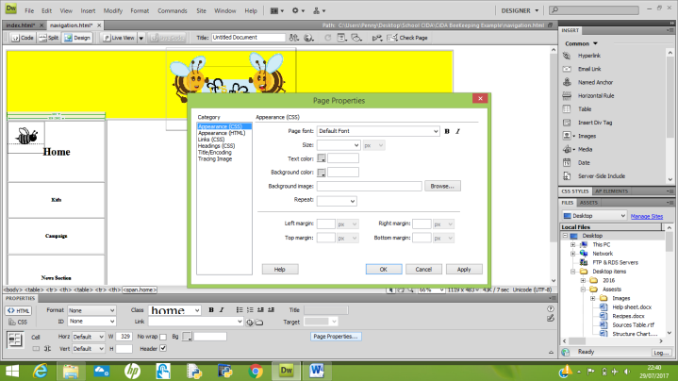
Select text colour and change to the colour of your choice

To change the background colour select the area you want to colour and click on Bg and select your colour choice.

Hyperlinking the pages together
Step 1
On the Index page select file >> save as

And save this as the name of the next page “Kids”

Tip: Make sure you are saving your work in the same
folder.

You will notice the page appear at the top
Repeat he same steps again select file >> save as>> Campaign
Again file >> save as >> Bee Keeping

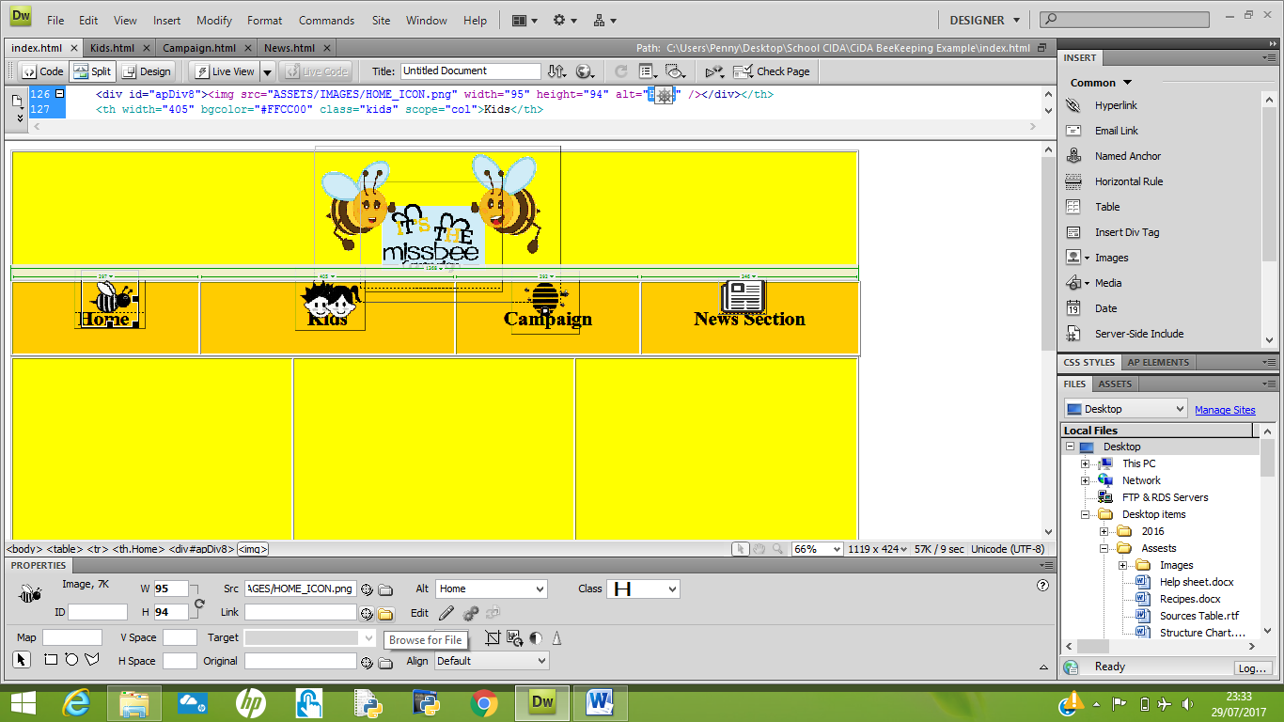
Step 2
Highlight the first button that you want to hyperlink ie. Home
Click on the yellow folder

Select Index/home page
The text Home will appear blue and under lined this means it has been hyperlinked!

Highlight the second button that you want to hyperlink i.e. Kids

Click on the yellow folder

Select the Kids page
Repeat these steps until you have highlighted each button.
Click save

Select then next page “campaign” and repeat the same steps
Highlight the first button Home
Click on the yellow folder

Select Index
Repeat these steps until you have highlighted each button.
Click save

Select the next page at the top and repeat the same steps

